016 TypeScript setup tsd

TypeScript Kata List – Blog Page

[TypeScript Kata List on GitHub](https://github.com/robertdunaway/katas-typescript)

# Duration

10 minutes

# Brief

Setting up TSD (TypeScript Definitions)

### For More Information

BING/GOOGLE: “TypeScript ”

# Instructions

Get tutorial folder or the entire katas-typescript repo.

Open the [before/*.sln] file and execute the kata.

Feel free to execute this kata multiple times because repetition creates motor memory.

# Github

* Before (start kata with this)
  + https://github.com/robertdunaway/katas-typescript/tree/master/016%20TypeScript%20setup%20tsd/before
* After
  + https://github.com/robertdunaway/katas-typescript/tree/master/016%20TypeScript%20setup%20tsd/after

# Kata

Install TSD, a kind of package manager for TypeScript Definitions.

npm install tsd -g

Now TSD is installed and you can run commands with it.

$ tsd

$ tsd -h

$ tsd --help

$ tsd –version

Create TSD files

npm init

NOTE: This creates the tsd.json and typings/tsd.d.ts files.

Get TSD definitions for Angularjs and its dependencies.

tsd install angular --resolve --overwrite --save

To reinstall TSD definitions

tsd reinstall --save –overwrite

To update with the latest definitions

tsd update --save –overwrite

Open any *.ts file and type “angular” and intellisense is activated.

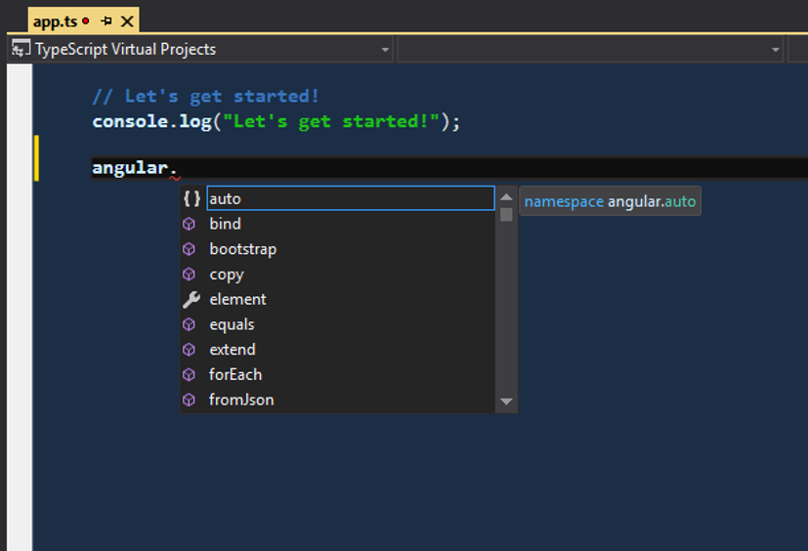

Let’s take this to the next level. At this point we have type definitions and that is great but now we need to manually update the definitions when changes are published and we are forced to check the Typings folder into source control. The problem with this is type script definitions are now source code.

Gulp can handle this for us. We will configure a gulp task to retrieve the latest type definitions and reinstall them when the project loads.

Create a new file at the root of the project named “gulp_tsd.json”. Add the following configuration to the new file.

{

"command": "reinstall",

"latest": true,

"config": "./tsd.json",

"opts": {

}

}

Add a task to the gulp file. First add a reference to the gulp-tsd plugin.

, tsd = require('gulp-tsd');

Then add this task.

gulp.task('tsd', function () {

return gulp.src('./gulp_tsd.json').pipe(tsd());

});

# Next

Take a few minutes and imagine more examples.